CHEM 1211Worksheet
Electronic Configuration of the Atom

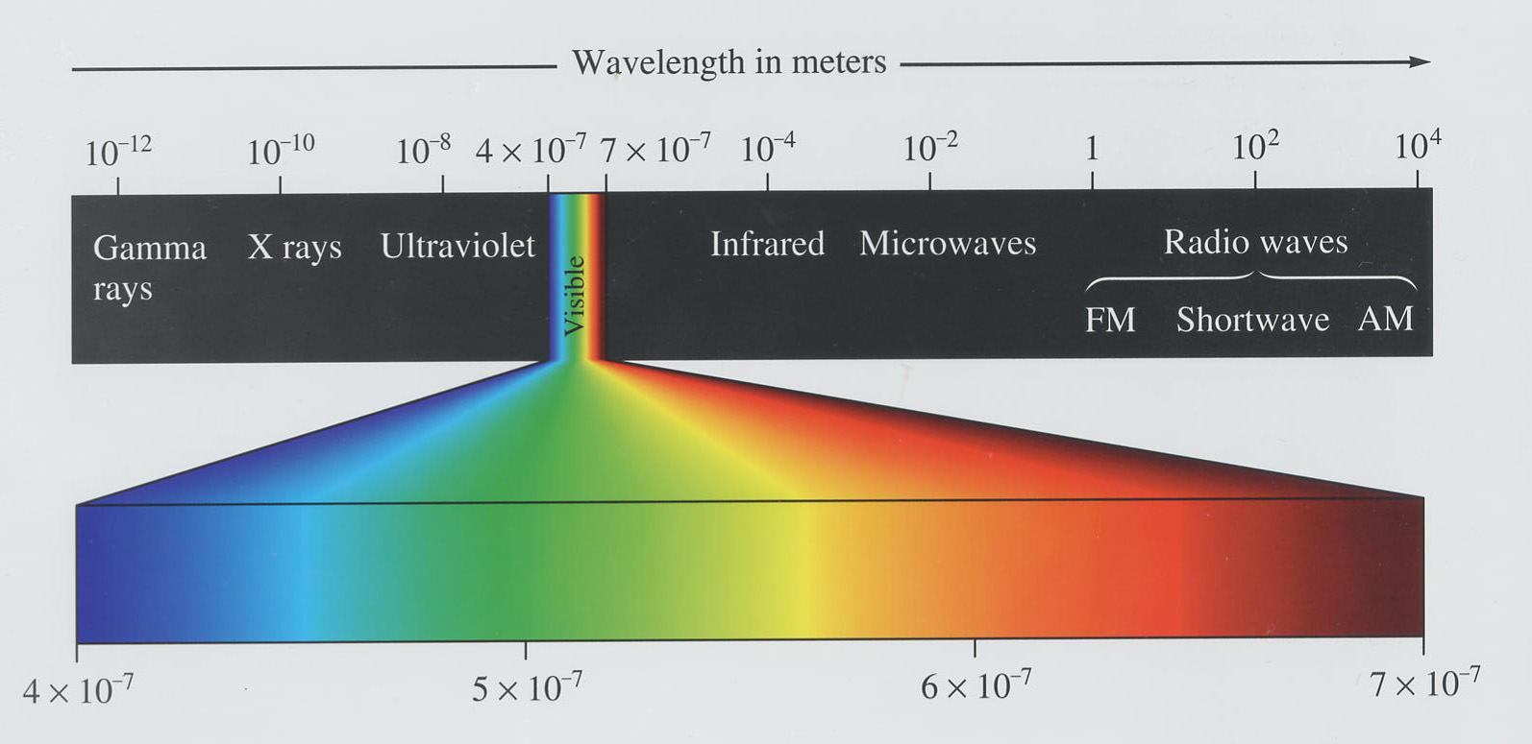
- A radiation source is measured to emit at a wavelength of 550 nm. Calculate the frequency of this radiation, and the energy associated with it. Is this radiation visible? If yes, what color would you expect it to be?

- The laser in a CD-player uses red light with a wavelength of 685 nm.
a. Calculate the frequency of this light
b. Calculate the energy associated with this light

- The minimum energy to eject an electron from an unknown metal is 6.7 x 10⁻¹⁹ J. Calculate the longest possible wavelength of light that is capable of removing an electron from the surface of the metal.

- State whether energy is absorbed or released for each of the following energy transitions in a hydrogen atom.
a. n = 5 → n = 4
b. n = 1 → n = 2
c. n = 3 → n = 5
d. n = 3 → n = 2

- $E_{n}=−\frac{2Π^{2}{\text{me}}^{4}}{h^{2}}\left(\frac{1}{n^{2}}\right)=\frac{−B}{n^{2}}$Utilize the Bohr equation for the hydrogen atom to calculate the following:
  - Energy values (E_{n}) for each energy level in the Hydrogen atom (n = 1, 2, 3, 4, 5 and 6).

  - The difference in the energy from energy level 5 to energy level 2.

  - What is the frequency associated with this change in energy?

  - What is the wavelength in nm for this energy change?

  - If an electron were to start in energy level five and go down to energy level 2, would energy be absorbed or released? Would you be able to observe? Explain.

  - Sketch a diagram/graph showing the energy levels of the Hydrogen atom, and illustrate on your diagram the electron going from energy level 5 to 2.

- For each quantum number l, give the corresponding orbital shape.
l value | orbital
0

1

2

3

- Provide the ‘name’ and sketch each of the atomic orbitals described by the following sets of quantum numbers.

  - n = 1; l = 0; m_{l} = 0; m_{s} = +1/2

  - n = 2; l = 1; m_{l} = -1; m_{s} = -1/2

  - n = 3; l = 2; m_{l} = +2; m_{s} = -1/2

- Provide the electron configuration for each atom.
  - H

  - C

  - F

  - Fe

  - Sb

