Crystal Structures
Practice Problems

1. Strontium forms a face centered cubic unit cell and has a density of 2.64 g/cm³. What is the radius of a strontium atom?

2. Chromium forms a body centered cubic unit cell. If the radius of a chromium atom is 125 pm, what is the density of chromium in g/cm³?

3. Shown is a unit cell for the salt made from magnesium and iodine. The purple balls areiodine and the green ones are magnesium. What is the formula for this salt?
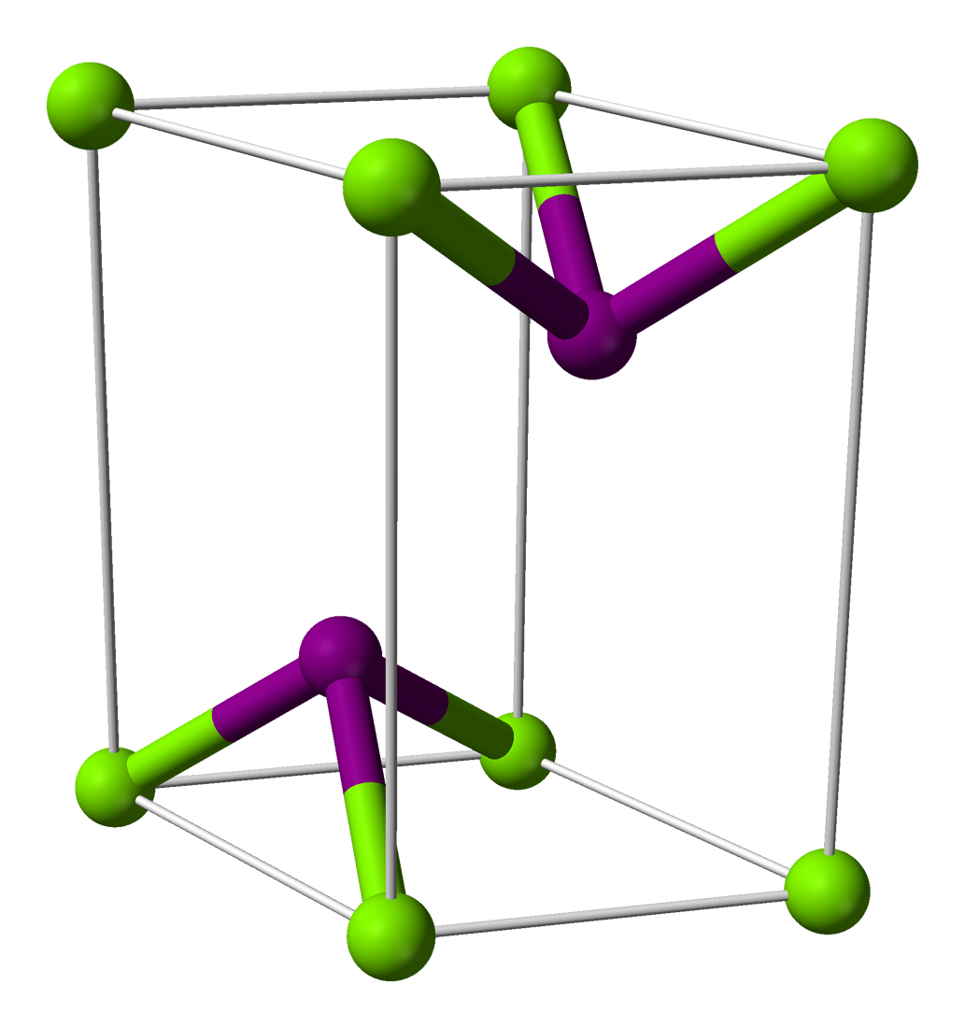

Multiple Choice
1. Iron is an example of
A) Ionic solid
B) Metallic Solid
C)Network covalent solid
D)Molecular solid
2. Ice, H₂O, is an example of
A) Ionic solid
B) Metallic Solid
C)Network covalent solid
D)Molecular solid
3. Face centered cubic is the same structure as
A)hexagonal close packed
B)cubic close packed
C)tetragonal packed
D)body centered packed
4. Calcium forms a body centered cubic unit cell. How many atoms are there per unit cell of calcium?
A) 1 B)2 C) 5 D) 6

5. The structure shown is
A) Face centered cubic B) Body Centered Cubic C) Simple Cubic D) none of these
