Buffers
Notes

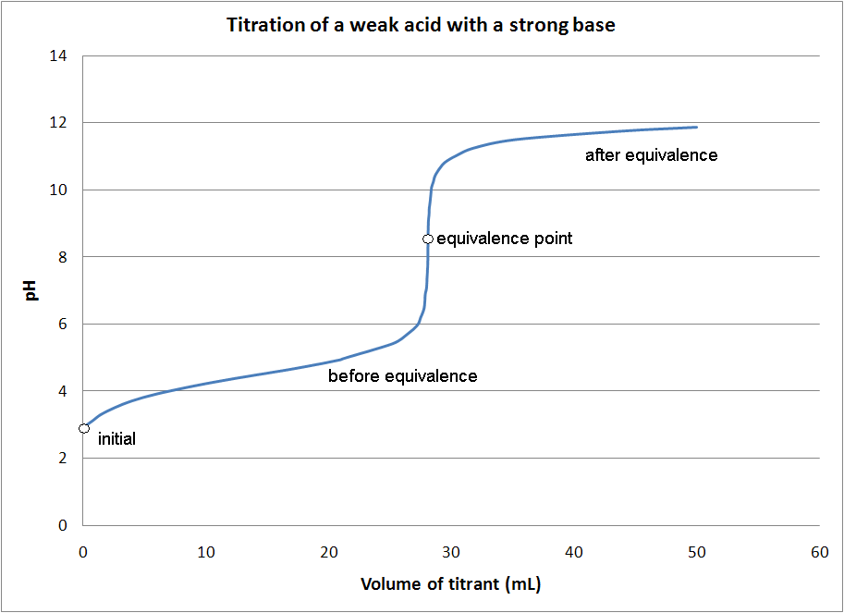

0.450 moles of acetic acid and 0.400 moles of sodium acetate were dissolved in water to make one liter of solution. The pKa for acetic acid is 4.76. What is the pH of the solution?

Henderson-Haselbalch Equation
pH =

Name | Formula | Ka | pKa
Acetic Acid | CH₃COOH | 1.76 x 10⁻⁵ | 4.75
Benzoic Acid | C₆H₅COOH | 6.25 x 10⁻⁵ | 4.2
Formic Acid | HCOOH | 1.77 x 10⁻⁴ | 3.75
Hydrocyanic Acid | HCN | 6.2 x 10⁻¹⁰ | 9.21
Hypochlorous | HClO | 2.9 x 10⁻⁸ | 7.54
Propanoic Acid | CH₃CH₂COOH | 1.4 x 10⁻⁵ | 4.85

What weak acid and conjugate base would you use to make a buffer with a pH of 3.6?

How many moles of formic acid and how many moles of sodium formate are needed to make a liter of 0.500 M formate buffer with a pH of 3.60?

When strong base is added to a buffer it is neutralized by the weak acid.

When strong acid is added to a buffer it is neutralized by the weak base.

0.0150 moles of NaOH was added to 500 ml of an acetate buffer that was 0.200 M acetic acid and 0.195 M sodium acetate.
The pKa for acetic acid is 4.76.
What was the pH of the original buffer solution?

What was the pH after the NaOH was added?

How many moles of HCl need to be added to 500. ml of a 0.250 M potassium acetate solution to make a buffer with a pH of 4.65? The pKa for acetic acid is 4.76.

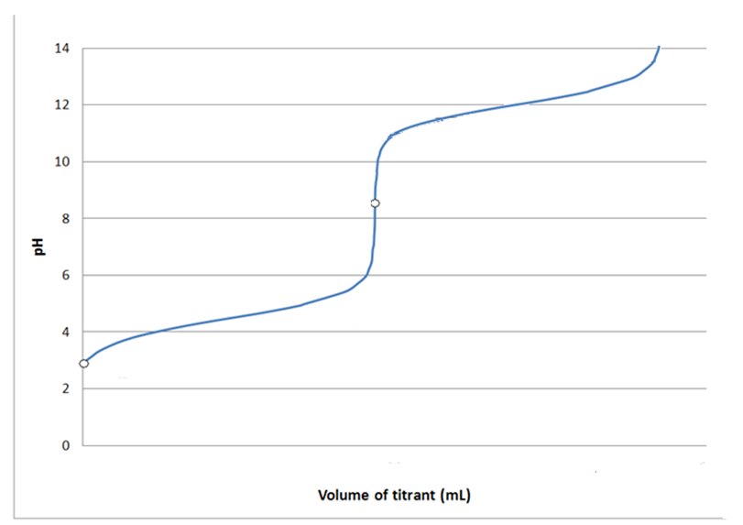
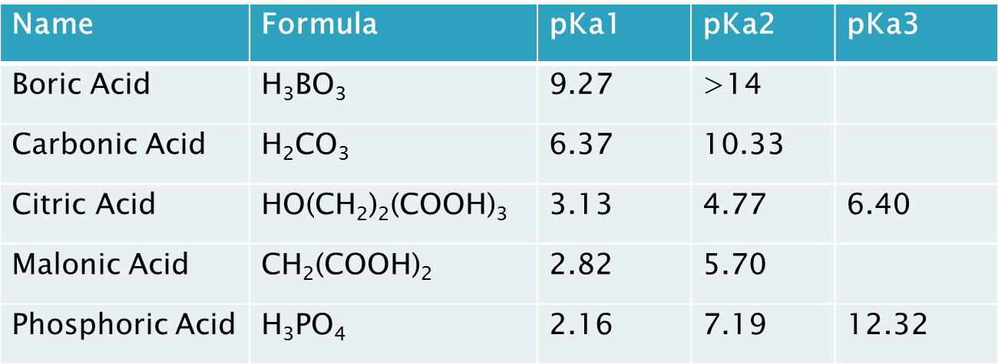

What is the pH of a solution made from 0.400 moles of sodium bicarbonate (NaHCO₃) and 0.385 moles of sodium carbonate (Na₂CO₃) in 500. ml of solution?

