Nomenclature

Covalent compounds contain only
_________________________.
Ionic compounds contain a ____________________ and/or a ________________________.

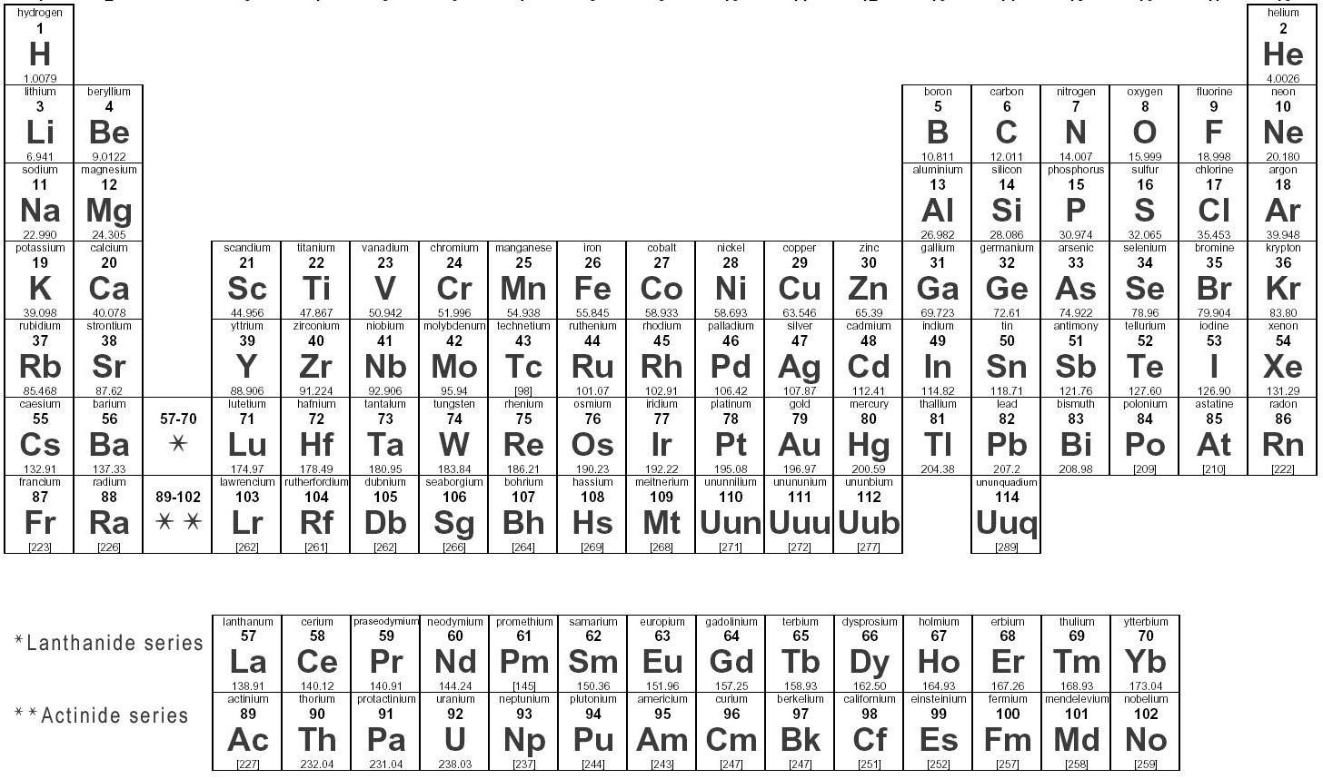

Prefixes for Covalent Compounds
Number | Prefix
1
2
3
4
5
6
7
8
9
10

Names of Organic Hydrocarbons
Number of Carbons | Formula | Name
1
2
3
4
5
6
7
8
9
10

Covalent Nomenclature
PCl₅
N₂O₅

Ionic Nomenclature; cations of known charge
Groups I and II, ____________, _________________, and ______________ always have the same charge.
NaCl
AlBr₃
Mg₃(PO₄)₂

Ionic Nomenclature; cations of variable charge
Fe₂O₃

Cr₂(SO₄)₃

When using Latin names the lower oxidation state ends in _______ and the higher one ends in ________.
FeO

Hydrates have _____________ molecules associated with the compund’s crystal structure.
CuSO₄ •5H₂O

