Empirical and Molecular Formulas
Molecular Formula =
Empirical Formula =
Glucose
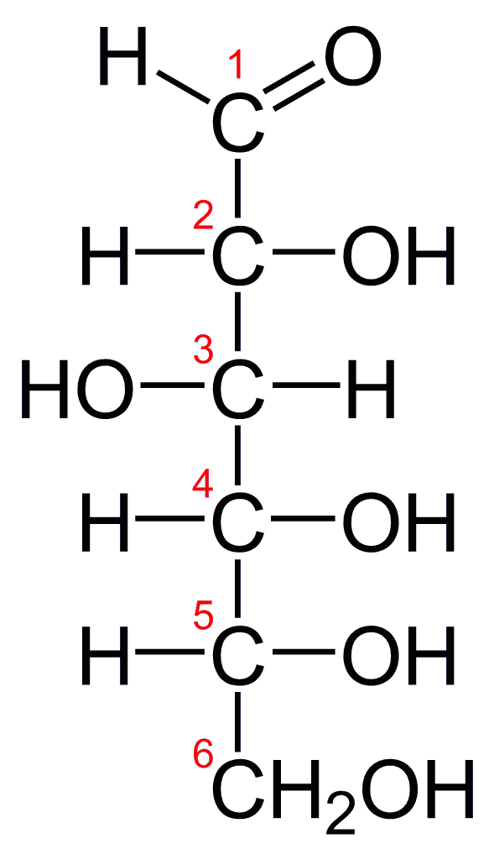
Molecular Formula =
Empirical Formula =

Calculating Percent Composition (Glucose) Using Molecular Formula
6 carbons weigh :
12 hydrogens weigh :
6 oxygens weigh :
1 glucose weighs :

mass percents
C: H: O:

Calculating Percent Composition (Glucose) Using Empirical Formula
1 carbon weighs :
2 hydrogens weigh :
1 oxygens weigh :
1 empirical formula unit weighs :

mass percents
C: H: O:

Finding Empirical Formulas
100 g of glucose contains _____________g C, _______________g H and ________________g O.

________________g C X 1 mole C =
12.01 g

________________g H X 1 mole H =
1.008 g

________________g O X 1 mole O =
16.00 g

Empirical Formula = Molecular Formula =
Aspartame
100 g of aspartame contains _____________g C, _______________g H, ________________g N and ________________g O.

________________g C X 1 mole C =
12.01 g

________________g H X 1 mole H =
1.008 g

_______________g N X 1 mole N =
14.00 g

________________g O X 1 mole O =
16.00 g
Empirical Formula = Molecular Formula =
Nicotine
100 g of nicotine contains _____________g C, _______________g H and ________________g N.

________________g C X 1 mole C =
12.01 g

________________g H X 1 mole H =
1.008 g

________________g O X 1 mole N =
14.01 g
Empirical Formula = Molecular Formula =
In combustion analysis the carbons are incorporated into _____________ and the hydrogens into _____________.
Example Problem
A 0.200 gram sample of a hydrocarbon containing only carbon and hydrogen was combusted completely producing 0.219 grams of water and 0.646 grams of carbon dioxide. What is the empirical formula for the hydrocarbon? The molar mass is 82.1 g/mole, what is the molecular formula?

