Titrations

Titration is a method to find the __________________ of an unknown.
Unknown =
Titrant=
HCl + NaOH H₂O + NaCl
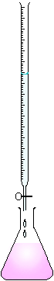
The

Tt

The equivalence point occurs when moles of _______________ = moles of _____________________.
The endpoint occurs when _________________________________________________________.
Phenolphthalein is __________________ in acidic solution and _________________ in basic solution.

Example: It took 25.0 ml of a 1.50 M NaOH solution to neutralize 10.0 ml of an HCl solution. What is the concentration of the HCl solution?

Example #2: 20.0 ml of a solution of H₂SO₄ was titrated with 1.50 M NaOH. It took 3.12 ml of the NaOH solution to reach the endpoint. What was the concentration of the original H₂SO₄ solution?

