Light and the Electromagnetic Spectrum

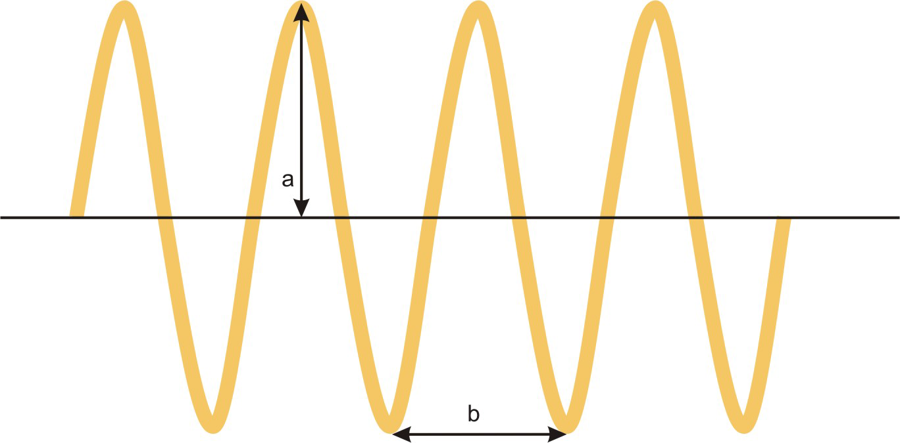
λ =
ν =
c =

What is the wavelength of a 2.4 GHz wireless router?

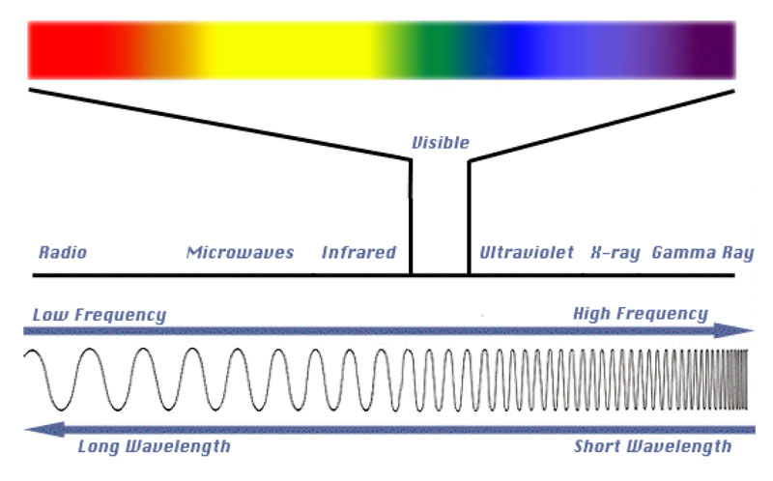
E =
h =
What is the energy of light emitted from a red laser point? The wavelength of the light is 635 nm.

What is the energy change when an electron moves from n=2 to n=3 in a hydrogen atom?
E = -2.178 x 10⁻¹⁸ J (Z² / n²) Z =

What is the wavelength when an electron moves from n=2 to n=3 in a hydrogen atom?

DeBroglie wavelength λ = mass must be in ________
velocity must be in_____________

What is the Debroglie wavelength of a 45.93 g golfball travelling at 95 mph?

